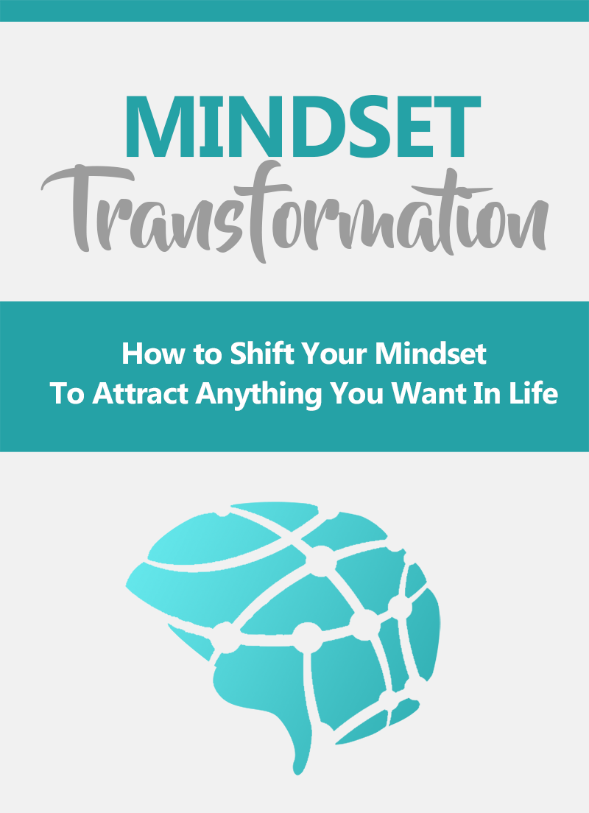

Disclaimer
This e-book has been written for information purposes only. Every effort has been made to make this eBooks as complete and accurate as possible. However, there may be mistakes in typography or content. Also, this e-book provides information only up to the publishing date. Therefore, this ebook should be used as a guide - not as the ultimate source.

The purpose of this ebook is to educate. The author and the publisher does not warrant that the information contained in this e-book is fully complete and shall not be responsible for any errors or omissions. The author and publisher shall have neither liability nor responsibility to any person or entity with respect to any loss or damage caused or alleged to be caused directly or indirectly by this eBook.

About the Author

Bishop Dr, James R. Rice is an Spiritual Life, Health, AND Empowerment Coach who loves sharing knowledge and helping others.
Bishop is a passionate person who will go the extra mile and over-deliver.
Bishop's words of wisdom:
"I believe that knowledge is power. Everyone should improve themselves and/or business, no matter what stage in life they're in. Whether it's to develop a better mindset or to increase profits. Moving forward is key."

Table of Contents
Introduction: It All Starts With Your Mind 6
Chapter 1: Understanding Your Brain – Some Basic Psychology 10
Chapter 2: The Power of Neurotransmitters 15
More Neurotransmitters and What They Do 17
Neurotransmitters for Incredible Abilities 19
Chapter 3: Improving Your Mental Health With the Right Food and Sleep 22
Making Use of Your Biology 24
Combating Stress 25
How to Upgrade Your Mental Energy 26
Chapter 4: Mindfulness and CBT for Improving Your Mindset 28
It’s All About Perception 29
The Idea Behind CBT 31
Chapter 5: The New You – Dressing for Success and More 36
What is the Law of Attraction? 37
Change from the Outside In 39
Chapter 6: How to Think About Failure and Risk the Healthy Way 40
Chapter 7: How to Know What You Want and Go After It 43
Vision, Not Goal 44
Chapter 8: 5 Powerful Exercises for Increasing Your Confidence 48
Understand What Confidence Is 49
Take Challenges 50
Visualize Success 51
Chapter 9: A Simple Workout Anyone Can Stick To 53
The Workout 53
Chapter 10: How To Maintain a Positive and Happy Mindset 56
The Gratitude Attitude and Other Techniques 58
Conclusion and Summary 60

Introduction: It All Starts With Your Mind
No matter what it is you want to achieve in life, what makes you happy, or how you hope things are going to turn out – it all starts with your mind.
That is to say, that your mind – and your mind set more specifically – is responsible for how successful you are in any given career or pursuit, how others see you, your health, your physical strength and even how happy you are with what you have accomplished.
Any change you want to create in your life starts with the decision to make that change. That alone is enough to mean that all change necessarily must come from within to begin with. It is then your conviction about that change that ensures you’re able to accomplish it, your planning and your determination. And finally, it is your perception of that change that determines whether or not you are content with it.
Take a look at any of the most successful people in the world. One thing they almost always have in common is an absolutely unwavering commitment and determination to what they want to achieve. Take Arnold Schwarzenegger for instance – reportedly, he was so determined to become a champion bodybuilder that he would even break in to the gym on the days when it was closed in order to train. He once even snuck out of army barracks during his conscription in order to attend a competition!
People who are truly committed to what they want to achieve will be more than happy to wake up at 5 am every morning in order to workout, to work on their project, to research, to learn or to train. They never tire and they never simply give up.
This same commitment and passion is what helps you to focus on boring work, to finish early or to see breakthroughs that you otherwise might have missed.
And simply having the conviction and belief that you can and will success is often enough to draw people to you and to increase your chances of success. When you are truly driven and when you have complete faith in yourself, you exude passion and confidence – which inspires others and convinces them to take risks on you. This is called the ‘law of attraction’ and in a nutshell, it means that for others to believe in you, you first need to believe in yourself!
But perhaps you don’t need any of those things? Perhaps you already have everything you already need to be completely happy but the problem is simply acknowledging that and being content with it. Perhaps it’s just the ‘hedonic treadmill’ that keeps you in a perpetual state of dissatisfaction and prevents you from living life to the fullest and making the most of your opportunities, experiences and relationships.
We’re about to change all that. We’re about to teach you the skills you need to really take control of your own mind and to thereby take control of your body and even your situation. As Jackie Chan says ‘don’t let the situation change you, change the situation’.
In this book, you will learn:
- How your brain works and how this impacts on your experiences and your capabilities
- How you can take control over the workings of your brain in order to alter your emotional state and more
- How controlling your own mind can help you get into the best shape of your life
- How to be happier and more content
- How to manipulate others by understanding the workings of their mind
- How to increase your confidence and use the ‘law of attraction’ to get whatever you want in life
- How to overcome your fears and other obstacles
- How to increase your energy levels and never have a lazy evening again
- How to accomplish incredible focus and tap into ‘flow states’
- How to be engaging, charismatic and attractive
- And much more…

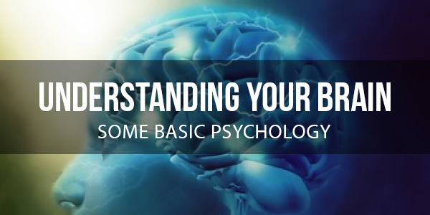
Chapter 1: Understanding Your Brain – Some Basic Psychology

What most of us aren’t aware of, is just how much of a slave we typically are to our biology – and especially when it comes to neuroscience.
We have the illusion of self-control. That is to say that we feel like we choose what we do and we choose how we feel. If we’re angry, it’s because of some injustice – we’ve thought about the situation and decided that anger is the correct response.
If you’re happy, it’s because all is well with the world and you’re content.
We then take all this information and decide what we want to do next and how we’re going to perform at that activity.
But the reality is that we are not in charge of our brains. Rather, our brains are in charge of us. And they’re largely controlled by our bodies and our situations too. Unless we understand the workings of our brain and we’re able to take conscious control over the processes that dictate our moods, our motivations and more, then we are destined to remain at the whim of certain chemicals – and completely oblivious to that fact.
Who Are You?
Okay, so let’s go deep right off the bat. Who are ‘you’? What makes you, you?
The answer is your brain to a large extent. And your brain in turn is made up of billions of neurons – small cells that have tendril-like extensions reaching out and into the different corners of your skull. These neurons can be created, destroyed or changed via our experiences and they represent all kinds of things including memories, sights, smells, thoughts and ‘commands’ to move our body.
When an electrical impulse moves through a neuron, this means it is ‘firing’ and thus we experience whatever correlates with that firing. If you open up someone’s skull and use an electrode to stimulate individual neurons, then one might make someone see a point of red light, one might make someone move their arm and another might make them remember their Mother.
These neurons are all interconnected and the more often two neurons fire at once, the more connected they become. Thus, when one neurons fires, it is likely that others around it will fire depending on the strength of the firing (called an ‘action potential), other activity in the area and the strength of the connection. Some ‘clusters’ of neurons form the major brain structures like the occipital lobe, motor cortex or hippocampus which are responsible for particular behaviors. Other neurons reach from one end of the brain all the way to the other!
Already you can see how your brain is not always entirely under your control. If you see something specific, then this will cause certain neurons to fire based on your memories and understanding of that object. But it might also cause surrounding neurons to fire, depending on the associations you’ve formed during that life-time.
And when certain neurons fire, they cause particular emotions. That’s because neurons communicate across synapses – small gaps between the end of one neuron (the axon – which is like a tail) and the dendrites (like arms) of another.
At the end of each axon is the synaptic knob, which is filled with chemicals called neurotransmitters, held inside ‘neuro vesicles’. When the synapse fires, it causes these neurotransmitters to be released and that then alters the behaviour of the transmission and the surrounding cells. Some neurotransmitters are ‘excitatory’ and make other neurons more likely to fire. Others are ‘inhibitory’ and make them less likely to fire – and more suppressed.
Others have more complex roles. Some for example will make you more likely to remember something, while others will make you feel happy or sad. This is what controls the way you ‘feel’ about certain experiences.
Neurotransmitters are linked closely with hormones too. Some hormones act like neurotransmitters while some neurotransmitters can act like hormones. Essentially, hormones are longer lasting and generally produced in the body, while neurotransmitters have shorter-lasting effects and are produced in the brain. Even hormones produced in the body though are largely triggered by the pituitary gland, which is located in the brain.
See a lion for instance and your brain will sit up and take notice owing to the associations you form with that image. Relevant neurons will fire and because those neurons are coded with danger, they will release a number of neurotransmitters like dopamine and cortisol to increase activity and say that something important is happening. This increased activity causes more of the brain to light up and areas around the hypothalamus will then begin to trigger activity in the pituitary gland, producing adrenocorticotropic hormone. The adrenal gland will also be triggered at this point, releasing the hormone epinephrine, which is essentially a form of adrenaline. This is then what causes changes in the sympathetic nervous system.
This triggers physiological changes, including:
- The acceleration of the heart and lungs
- Vasoconstriction (thinning of the blood vessels)
- Dilation of the blood vessels leading to muscles
- Dilation of the pupils
- Inhibition of erection
- Sense of dread/anxiety
- Tunnel vision
- Thickening of the blood to encourage clotting after injury
- Pain reduction
- Contraction of the muscles
- Shaking
- Suppression of digestion and immune function
Essentially, the body now directs all blood, oxygen, nutrients and resources to the muscles and the brain, in order to aid in combat, escape or other physical activity.
All this is involuntary and all of this is controlled entirely by automatic responses throughout your body. And it completely changes the way you now think and the way your body operates. It changes the way people see you and it drastically effects the way you perceive everything that happens subsequently.
But it’s not just during times of high stress that you see such uncontrolled changes throughout your body. And there are many complex interactions of chemicals and hormones going on inside your body all the time…

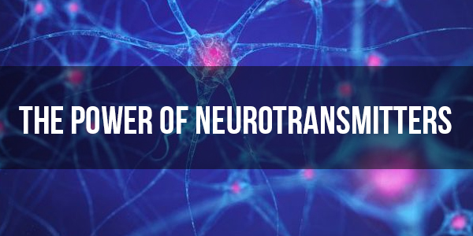
Chapter 2: The Power of Neurotransmitters

In the case described in the last chapter, we saw how releases of dopamine, epinephrine and cortisol among other neurotransmitters could result in the fight or flight response.
But something very similar, albeit much milder also happens when you experience chronic stress. Chronic stress is the kind of stress that ‘doesn’t go away’. This is not a lion but rather an impending deadline at work, wedding planning, property investment, debt, relationship problems…
This triggers a very similar stress response, which results in continued changes in your body such as suppressed immune function and digestion, a certain amount of tunnel vision, dread and anxiety etc. So when you’re stressed for long periods, this negatively affects your ability to relax and to enjoy any experiences – but it also impacts negatively on your health in more ways than you might immediately expect.
Dopamine makes us more driven and focussed for instance but only on the thing that is causing the stress. This reduces activity across our brain so that we are more tightly focussed on specific thoughts, emotions, ideas and inputs. That’s why ‘eustress’ can actually be a good thing and make you more likely to revise for an exam. But it has also been shown in studies to make us less creative because we’re less able to let our mind explore different, diverse ideas.
Likewise, stress also makes it hard for us to focus on anything other than that thing that has our attention.
What’s more, is that stress can seriously undermine your ability to impress or influence others. That’s because stress is a sign that you’re nervous or afraid. If you give of these signs in front of a competitor, then it makes you appear to be less confident and thereby sends the signal that they must be the alpha to your beta. Likewise, if you are anxious when approaching a potential mate, it suggests on an unconscious level that they must be a better potential mate than you – that they are out of your league or at least that you perceive that to be the case!
As you can see then the ability to control your stress response can be a fantastic asset and help you to focus more when you need to, to run faster and to fight harder – or just to appear completely confident and in control in stressful situations.

More Neurotransmitters and What They Do
Conversely, other neurotransmitters can be released in response to pleasure, exercise, sunlight, tiredness, darkness, excitement and more. And these all affect our mood and our ability to focus in other ways.
Serotonin is the neurotransmitter that we think of as the ‘happiness hormone’. This is what makes us feel content and happy and it also has a range of other roles such as suppressing pain and decreasing appetite by stimulating the production of leptin.
Melatonin is the neurotransmitter that makes us sleepy!
GABA is an inhibitory neurotransmitter that reduces activity in the brain and can thereby suppress stress and further encourage sleep.
Dopamine is essentially a neurotransmitter that is related to goal-oriented behavior. It makes us more focussed and increases memory among other things.
Acetylcholine is one of the principle excitatory neurotransmitters and also plays an important role in memory.
Nitric Oxide is a vasodilator and helps get more blood to the brain and muscles. It also activates neurons that aren’t directly connected and thus has an important role in helping us to wake up.
Testosterone is the ‘male hormone’ that is linked to aggressive thoughts and behaviors as well as drive and confidence.
Estrogen is the female hormone and can have a big impact on mood.
Cortisol is the ‘stress hormone’ and makes us more alert while creating feelings of dread. It’s also linked with appetite, this time making us hungrier via another hormone/neurotransmitter called ghrelin.
Substance P is the neurotransmitter related to the transmission of pain. It also happens to be linked to anger according to some recent research.
Oxytocin, often called the ‘love hormone’, makes us more agreeable and creates feelings of loving protection and bonding.
Glutamate is another of the most abundant excitatory neurotransmitters and exists in vast quantities compared to any other neurotransmitter.
Anandamide is the ‘bliss’ neurotransmitter and also appears to stimulate creative thinking.
Once again, these neurotransmitters are released in response to our experiences and thoughts. When a mother sees her child, her brain floods with oxytocin which makes her more likely to bond with the child and feel the need to connect.
When you go on a rollercoaster, your body produces epinephrine and anandamide. When you have just had a great day out, you will be filled with serotonin and feel happy and positive.
In short, your happiness, productivity, creativity, attractiveness, relationships and much more are all responsible for different quantities of these various neurotransmitters.

Neurotransmitters for Incredible Abilities
Certain ‘states’ can be triggered via the release of specific neurotransmitters and this can be incredibly desirable/positive in some cases.
One example is the much-studied ‘flow state’. A flow state is a term for that moment when everything seems to fall into place and you are able to perform at your very best. This results in absolute focus, heightened reactions, improved problem solving and more. It happens when you’re snowboarding for instance and the world seems to suddenly slow down, allowing you to pull off incredible moves with expert timing. It also happens when you’re so lost in your work that you forget to the toilet or even look up from the computer. And it happens when you talk to a friend all night without realizing how long the conversation has been going.
In short, this experience is what total, creative focus feels like. And chemically, it is very similar to the fight or flight response but minus the sensation of fear or dread that normally comes from that. Instead, there seems to be a release of anandamide, which enhances creative problem solving while creating that sense of exhilaration that is so addictive to adrenaline junkies. At the same time, brain scans show that the prefrontal cortex – the part associated with planning and self-doubt – appears to shut down. This is what removes our sense of time passing and allows us to stay completely fixed on the moment. It’s known as ‘temporo-hypofrontality’.
It is thought that all major athletic records were set by flow states and that most highly successful start-ups get to where they get to thanks to flow states.
So imagine if you could trigger a flow state at will and thereby achieve complete focus and perfect problem solving…
The opposite of this state is what’s known as the ‘default mode network’. This is a network of brain structures that light up when we are completely lost in thought, often while our bodies carry out mundane tasks like showering. This is what allows us to explore diverse regions of our brains and find new connections between ideas – and it’s what is believed to have helped Einstein dream up special relativity while working at the patent office.
The ‘flashbulb memory’ meanwhile shows us how our brains can be capable of laying down much clearer memories during times of extreme shock (such as the moment you heard about 9/11 for instance). Likewise, ‘hysterical strength’ shows how a strong enough fight or flight response can actually increase muscle fiber recruitment to the point where women have been able to lift cars off of their children trapped underneath.
One underground movement that is interested in the idea of using neurotransmitters to accomplish more is the ‘nootropics’ movement. Nootropics are ‘smart drugs’ which tend to work by blocking certain neurotransmitters and encouraging the production of others. These can work like the film ‘Limitless’ but on a much less powerful scale – slightly increasing memory, focus or even confidence.
The problem with nootropics is that they often come with side effects, haven’t been tested in the long term and generally make it harder for us to switch mental state as we need to. It’s no good being highly focussed if it means your creativity will be suppressed!
Luckily, there are other ways to encourage the production of the correct neurotransmitters to invite the mental states we want…

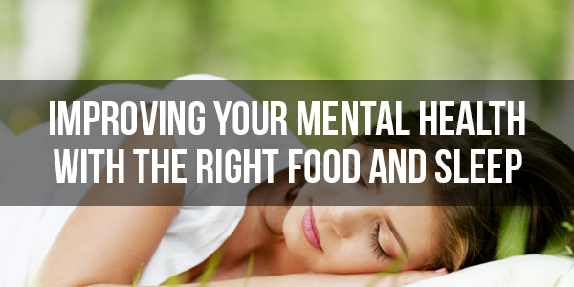
Chapter 3: Improving Your Mental Health With the Right Food and Sleep

What’s key to understand here is that it’s not just our thoughts that lead to these changes. Just as important is our biology and our lifestyle and our bodies and minds exist in a tightly linked cycle of activity.
For instance, when you eat this results in an increase in serotonin. Why? Because foods – especially carbs – contain an amino acid called tryptophan. When blood sugar increases, the body responds by releasing insulin which triggers the absorption of glucose from the blood to be used for activity or stored as fat. But tryptophan does not get absorbed and as such, it remains in the bloodstream. This then gets circulated to the brain, where it is converted into serotonin – that’s because tryptophan is a precursor (building block) for serotonin.
This is why your mood tends to improve when you’ve eaten. And this then results in the release of ghrelin to signal that you’re getting fuller and to prevent you from over eating.
Later on, that serotonin converts into melatonin – the sleep hormone. This is why everyone falls asleep after Christmas dinner! That melatonin reduces activity in the brain and this then triggers the release of other inhibitory neurotransmitters like GABA.
Did you know that darkness also triggers the release of melatonin?
And meanwhile, the longer you stay awake, the more adenosine (another inhibitory transmitter) builds up in the brain. This is partly what gives us ‘brain fog’ after a long hard day because it is a by-product of the energy process used in brain cells.
What all this means, is that after a long day and big meal, you are sure to start getting tireder at the end of the day and find it harder to wake up and do something productive. That’s not you being lazy or disinterested, that’s you being at the whim of your biology.
Now let’s say that we want to wake ourselves back up. What do we do? One simple option is to go outside or shine a bright light – sunlight triggers the release of cortisol, which along with nitric oxide will help to wake us up. This is why we should avoid looking at phone screens when we’re getting ready for bed.
Or how about jumping in a cold shower? This stimulates the release of epinephrine, norepinephrine and testosterone – waking you up and making you much more focussed. It’s the adrenaline that causes the hairs to stand up on your body.
Loud noises can create enough shock to wake you up and so too can hunger. When we’re hungry, we have low serotonin in our brains which in turn increases the cortisol – stress hormone – ratio. That’s why we get anxious when we’re hungry and it’s why some people also get ‘hangry’.
There are all kinds of other interactions like this that can have a huge effect too. For instance, as pain is linked with anger, this explains why we’re cranky when we have aches and pains. It also explains why if you keep flicking your dog’s ear, it will eventually turn around and bite you…

Making Use of Your Biology
So what can we take from all this?
For starters, it’s useful to recognize the role of your natural ebbs and flows and your biology. In other words, try not to get too alarmed if you find yourself feeling very stressed or very tired. Likewise, try not to let anger cloud your judgement. Often we will shout at our loved ones when we’re angry or stressed partly because our perception of events has changed and had a negative slant. We might even find ourselves thinking things like ‘all they do is take advantage’.
Remember: that’s angry you. That may well simply be the result of cortisol, of testosterone or of all three. Try not to put stock in what you’re thinking.
This also means you can ‘fix’ your mental state in all manner of ways. You can wake yourself up with a cold shower and some blue light (blue light being the term used to describe light with the same wavelength as the sun). If you’re in a bad mood, then you should try to increase serotonin which you can do with food – or more sensibly by increasing vitamin C. Something else that triggers the release of serotonin is exercise! This is what causes what we know as the ‘runners’ high’.
If you want to perform at your very best, then use this information to try and improve your sleep. This will help you to wake up with your brain feeling far more refreshed and with much less ‘brain fog’ slowing you down and making you groggy.
Another tip is to sync your routine to these natural rhythms. If you’re going to feel tired and content after a meal, then it’s important to make sure that you’ve already done everything you want to do before you sit down to eat. Want to be more productive in the evenings? Shift dinner back half an hour! Likewise, recognize that you’re less likely to be productive straight after you’ve eaten at lunch. Conversely, if you’re going to try and think creatively – do it when you’re relaxed and calm.

Combating Stress
Also useful to know is that you can use your body to calm stress and event eliminate what would otherwise be a panic attack. That’s because our sympathetic nervous system – which controls our fight or flight response (as well as our opposite ‘rest and digest response’) – is tightly linked with breathing and heartrate. When you breathe quickly, it makes you more stressed and increases your heartrate.
Conversely though, if you breathe more deeply and more heavily, this helps to encourage a much calmer response and puts you more in the rest and digest state. Breathing deeply is thus one of the best ways to calm yourself down and one of the best ways to prevent serious anxiety.

How to Upgrade Your Mental Energy
What’s more important of all though, is that you ensure you have the right diet and that you are in good shape. This will transform the performance of your brain by drastically increasing the ability to create neurotransmitters as needed and by increasing the amount of energy your brain receives.
One way to do this is to consider using some form of multivitamin tablet. This should contain vitamins like B12 and B6, which are used to supply the brain with energy as well as to help create a large number of neurotransmitters. Also used in the creation of many neurotransmitters and hormones are vitamin D, vitamin C, magnesium, zinc and more. If you make sure you are getting these in your diet, then you will find it easier to switch from being highly focussed to being relaxed and creative and you will find your brain lasts longer before getting tired. Also particularly important is choline, which is a precursor to acetylcholine found in eggs – this can help improve your sensory perception, your alertness and your memory all at the same time! Amino acids found in protein are also critical for a wide range of neurotransmitters.
Other nutrients that are very important are those that improve the energy and function of the brain. Any vasodilators for instance, such as garlic, will help to get more blood and more oxygen to the brain helping you to stay alert for longer. Creatine is a bodybuilding supplement also found in red meats and this is great for reducing adenosine and also increasing mental energy – studies show that this alone can be enough to boost IQ! Omega 3 fatty acid improves cell membrane permeability, which means that neurons are better able to communicate with one another. Exercising regularly will help you to create more neural connections in your brain, increasing your ability to learn via heightened plasticity (and brain derived neurotrophic factor). This will also increase your body’s energy efficiency and help you to experience less stress.
In short, it is highly important to eat a nutrient dense diet and to train hard if you want to perform at your mental best. Get more nutrients and substance, avoid junk food and ‘empty calories’ (which spike the blood sugar and throw our entire system out of whack), sleep well, run and lift weights.
As you do this, your brain will instantly start to become hardier, more efficient and less groggy on the whole. And your performance and productivity will also grow to reflect that.

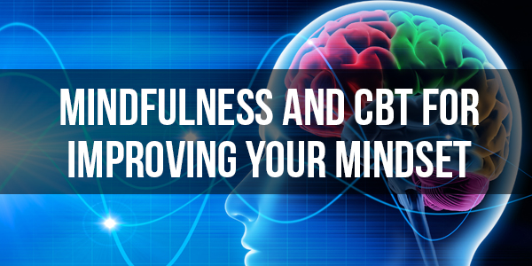
Chapter 4: Mindfulness and CBT for Improving Your Mindset

By using the techniques in the last chapter, you’ll find you’re able to increase your wakefulness, your mood and your general performance on a regular basis.
But now we come to the next trick – changing your mood instantly and switching from one mental state to another. What we really need to be able to do in order to perform at our very best is to switch to a stressed and motivated state when something requires our attention, to become angry in a controlled manner when we’re arguing and to switch off and relax from work when we get home in order to allow our brain to recover and to actually enjoy ourselves. Having an understanding of our neuroscience will help and so will having a good foundation of health. But now we’re going to take full control of our mental state and our attention.

It’s All About Perception
As mentioned earlier, our experiences are largely what control our emotions. Simply seeing a lion is enough to trigger a cascade of different changes in the brain that ultimately result in us becoming highly aroused both mentally and physically.
When tired, you could wake yourself by taking that cold shower or by seeing a lion!
When you’re drunk, it’s because you have excess GABA in your brain. But if your friend gets hurt, the rush of epinephrine and dopamine will be enough to actually make you feel sober and sharp again so that you can deal with the crisis.
But what if the lion wasn’t there and you only thought the lion was there?
What if the lion was there and you didn’t see it?
Ultimately, it is not the actual lion that triggers the response but rather your perception of that lion and your beliefs about the lion.
Put it another way: if you were to see a lion and you didn’t know what a lion was, then you probably wouldn’t have the same fight or flight response – you might even think it looked cute and get an oxytocin release instead!
It’s your understanding of the situation that impacts on the way you react to it and this in turn changes the way you feel and the way you behave.
And this is actually what happens all the time throughout our lives to a lesser extent. This is why some people are calm and relaxed all the time (we call them ‘laid back’) while other people are constantly stressed and anxious.
Let’s imagine you’re in your office and you have a very bad deadline that you don’t think you can meet. Some of you might now feel incredibly stressed and thus experience that fight or flight response. But others among you might not have that response at all and you may instead find you’re able to stay very calm and collected.
There’s of course an ideal middle ground here – being too stressed is bad for your health and can actually cause you to become less productive in some cases (the response is sometimes actually referred to as the fight, flight or freeze response!) while being too relaxed as mentioned can cause you to end up not actually doing anything about the situation.
The simple fact of the matter is that in these situations, some people see a lion and some people see a cat. The scenario is the precise same but their reaction to that situation can be very different. This is based on your life experiences, diet, health and personality – but you can take control of it once you know how.

The Idea Behind CBT
CBT is ‘cognitive behavioral therapy’, which in turn is a type of psychotherapeutic intervention that is based almost entirely around the concepts we’ve just discussed. This asserts that our behavior is a result of our associations (this is behaviorism) and of our thought processes that actually allow us to reinforce an idea in our heads.
So when faced with a stressful situation, you will be stressed partly because of the beliefs and associations you hold regarding that situation. At the same time, you’ll then start playing out what you expect to happen in your head and when this happens, areas of the brain fire almost as though that thing were really happening. You might imagine getting fired, having your house repossessed, or being injured depending on the scenario.
This then causes the release of even more stress hormones, just as though you were really in those situations and you can end up anxious, aroused and potentially less effective. This is where a lot of phobias come from but it’s also what can make us less self-confident, less likely to take positive risks and generally less successful than we otherwise could be.
So CBT aims to change this, partly by creating new associations and partly by changing the way you think and changing what you’re visualizing. There’s more to it than that of course but this is the central concept and the tools used to this end are collectively referred to as ‘cognitive restructuring’.
So let’s say that you want to be calmer at work, or you want to overcome a fear of heights. How might you do that using CBT?
The first step would be to become more aware of your existing thoughts, beliefs and emotions. You can do this in a number of ways. One common tool is journaling, whereby you keep a journal of your thoughts, feelings and emotions pertaining to the thing that frightens you. This way, you can really deconstruct the thought process that is leading to your fear.
Another option is to use mindfulness. This is a form of meditation that doesn’t focus on making your mind blank but instead focusses on letting your mind become detached while you watch the contents of your thoughts. This process in itself is very calming and can help to prevent a fight or flight response.
Once you have the thoughts that make you stressed though – or you’re aware of what you’re visualizing – you can then go about deconstructing them. For example, if you’re afraid of public speaking then this might mean that you picture yourself stuttering and being laughed at. If you’re afraid of heights, you might think things like ‘I’m going to fall’.
What you don’t realize is that simply thinking these things is strengthening those neural connections and coding the experience as ‘bad’ and ‘dangerous’ making the response stronger in future.
So now you’re going to unravel those beliefs and try to remove them. One way to do this is with ‘thought challenging’. Thought challenging essentially means that you’re going to really analyze your belief and decide if it might actually be true or not. So if you’re afraid of being laughed at on stage, you’re going to think about how likely people really are to laugh at you and whether or not this is something that you would do in their position. The reality? Most people are kind enough and mature enough to just politely wait for you to get it back together. If anything, they’ll probably only sympathize.
You can also help this process by coming up with contingency plans. In other words, if you do stutter, what can you do to make it less devastating? Probably just make a joke of it to ease tension!
Also: do you really care if these strangers who you’ll never see again think any less of you?
Another scenario might be low level anxiety that you’re holding about your job because you’re afraid of being fired. Let’s say you made a big mistake on a report that won’t come to light for two weeks – now you’re worried you’ll be severely reprimanded.
So let’s address this situation logically with thought challenging: is your boss really that harsh and unfair? Aren’t there laws that would protect you? Can’t you explain that it’s an honest mistake? Could you blame it on your tiredness or stress at the time? If you really did get fired, wouldn’t you be able to land back on your feet? Now picture the way it’s much more likely to go and let that sink in. Suddenly, it’s not so scary.
In both these situations you have taken that mental lion and turned it into a small kitten! You’ve neutered the dragon and you can thus remain much calmer thanks to your new perception of the situation. And the more you practice this, the more you’ll find you start to adopt it and it starts to become a part of who you are. Suddenly, you’ll be able to stay calm and collected during all kinds of crises at work and eventually people will start to turn to you for advice whenever something goes wrong!
Another tool is even more powerful than this and it’s called ‘hypothesis testing’. The problem is, that in order for you to really be able to overcome a fear or phobia, you have to really believe what you’re thinking and visualizing. It’s not enough to just keep saying that it’s a cat and not a lion – you have to really believe it right in your heart.
So the next logical question at this point, is how you can convince yourself of your new thoughts and beliefs. And one way to do that is to use hypothesis testing – simply proving to yourself that your old beliefs were wrong and your new ones are right.
In the case of the person afraid of public speaking, what would that mean? It would mean actually making a mistake in public on person – or even standing there not saying anything for a while. You’re facing your worst case scenario, trialling the worst outcome and hopefully proving to yourself that there’s actually nothing to be afraid of. In doing this, you should find that no one laughs and people just wait politely. At this point, you now know that your fears were unfounded and you will find they bother you much less in future.
This is also a little like reassociation or exposure therapy. By consistently exposing yourself to the situation you used to be afraid of, you can create new associations and remove those old negative ones. You can even eventually become desensitized as you learn that there’s nothing to be afraid of. I’ve seen a paratrooper whose heartrate remained at 60bpm throughout the entire jump. Why? Because he’d done it hundreds of times before and his body knew that this was nothing to be afraid of.
You can work your way up to this if you’re unsure but just exposing yourself to these dangerous situations will eventually be enough to help you overcome an unwanted physiological response.
One of the most powerful and effective uses for this? Becoming socially bulletproof. Almost all of us have some kind of natural anxiety when talking to strangers and this causes us to have a minor stress response. As mentioned, this then makes us appear unconfident and sends the signal that we are the inferior party in the interaction – again, it all dates back to our evolution.
But if you keep exposing yourself to new social situations and even make them purposefully awkward, then eventually you can completely get rid of any anxiety you previously felt at all. Try going to a shop (not one near you) and ordering your items in a funny accent. You’ll find they politely nod and give you your things without saying anything. Try chatting to people you don’t know on the street – even picking up the phone a bit more and calling people by typing in random numbers. The more you do this, the more accustomed you’ll become to speaking with strangers and the less of a stress response you’ll have in future.
By the end, you’ll find that you’re perfectly able to speak with complete, calm confidence in almost every situation!

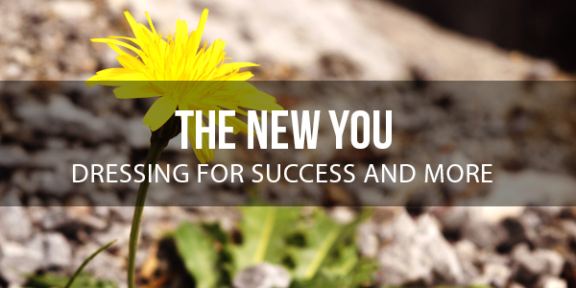
Chapter 5: The New You – Dressing for Success and More

Earlier we discussed how to become less stressed at a situation at work – by using thought challenging to break down the worst case scenarios and by coming up with contingencies. You’ve changed your perception of the situation by applying a little logic and in doing that, you’ve become much more calm and composed. We’ve also seen how we can change our response to new social situations, making ourselves incredibly calm and relaxed when talking to new people so that we come across as fearless.
This is where things start to change.
In the introduction, I mentioned very briefly the ‘law of attraction’. We saw how simply changing the way you feel about yourself would also change the way that others react to you. Let’s take a look at that in some more detail…

What is the Law of Attraction?
It might seem strange but most of us will buy more expensive gifts for our wealthier friends. This is proven by statistics and surveys and it’s surprising seeing as you’d think we’d want to buy more expensive items for the people who couldn’t afford them on their own.
But the reality is that wealthier people have more things and have a more expensive quality of item on display. To get them something they’ll like and to get them something that will fit in, we need to spend more on them. That and they probably spend more on us than our poorer friends, so we feel obliged to reciprocate.
This is an incredibly simple example of the law of attraction working. When you have more nice things, you actually attract even more nice things to you.
The same happens with money – you have to spend to accumulate and simply having more money means you’ll make more investment.
But it also works with what you believe about yourself and how you act. If you believe you’re highly capable at your job, if you genuinely aren’t stressed by things going wrong and if you act accordingly; then you’ll quickly find yourself rising through the ranks and getting to the top. When you have belief in yourself, so do other people.
One reason for this is that confident people tend to look more confident thanks to the way they dress and act. If you are very confident you might walk with a straight back and chest puffed out and you’ll probably buy nicer clothes and spend more time on your hair.
Simply doing this will make you look like someone who is more important and who is more successful. Now other people will assume you are more important and more successful and unconsciously your bosses will be more inclined to want to give you more responsibility.
They’ll also feel more confident sending you out to meet clients, while your colleagues might start turning to you for advice – because you look like you know what you’re doing. It doesn’t take long until doing all these things will make you the ideal candidate for that raise or promotion and then you become more successful.
The same is true for a guy approaching a woman in a bar. If he doesn’t believe in himself and hasn’t trained himself to be calm and relaxed, then he’s going to be sweaty, nervous and unattractive as a result. If he comes over and he believes in himself though and can control his stress response, he’s going to seem fun, confident and therefore attractive.
On an unconscious level, he is sending a signal to the woman that he is a good genetic bet for her offspring – he must be or why would he be so confident around her? There’s obviously something about him that makes him confident, whether that is wealth, strength, health or intelligence. This makes him more attractive and the woman’s neurotransmitters do the rest. Hello oxytocin, hello testosterone!

Change from the Outside In
We’ve focussed a lot so far on how to change your mindset from the inside out but you can also change it from the outside in. How? By simply treating yourself a little better – dressing better, looking after your health and investing some cash in your own happiness and your own development – you can help yourself to feel more confident and look more confident to others.
There’s an old saying that you should ‘dress for the job you want’. Likewise, it they say that the amount you spend on your haircut directly correlates with the money an employer is likely to entrust you with.
So spend that bit of time in the morning to make sure you’re looking your best. Exercise. And take care of your health. Women – try wearing a bold shade of lipstick to show that you’re not shy and not content to shrink into the corner. Guys – don’t go into work without bothering to iron your shirt, it just sends a signal that you don’t respect yourself enough to bother – or that you’re so disorganized that you couldn’t find the time or the energy to do it.
Changing from the outside in is never enough on its own. But when you change both inside out and outside in, then you’ll find the change is even more astonishing.

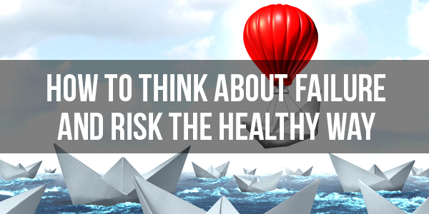
Chapter 6: How to Think About Failure and Risk the Healthy Way

Earlier, we discussed the powerful impact that just being a little more logical about stress at work could have. We then looked at the law of attraction and at how this makes you far more successful over time as people look at you as the person who is calm and in control.
But why is this? Why is it that most people aren’t better able to control their emotions and stay calm? Why is ‘panic’ our default response?
The answer is that our emotions have evolved in a much more dangerous time than we live in today. We are naturally risk averse because that is the attitude that would have given us the best chance of survival out in the African Savanah.
Let’s say you see an animal on the horizon and you don’t know if it’s a cat or a lion. In the wild, it really wouldn’t make sense to treat the unknown as a cat. Rather, it makes much more sense to assume the worst and to run.
But today that’s just not the case. Today, the ‘worst case scenario’ is really not that bad and is certainly not severe enough to put you in physical risk. The worst case scenario is your boss shouting at you, or a short period of financial hardship.
Risk aversion then is what gives you your advantage once you can get over it and it’s what will help you to seem the calmest and to make the ‘brave’ decisions. At the same time, it can be very beneficial to apply a little cognitive restructuring in order to change the way you perceive risks and challenges more generally. Think of these as opportunities to learn and to grow, to become stronger, and to give life some interest and excitement. When you look at them like this, you’ll be able to thrive rather than collapse under pressure.
Very often, it’s taking risks to ask someone out, invest in money, quit your job and start your own business, propose to your partner… all these things that give life meaning and color. And even if they go wrong, at least you tried.
And if you don’t learn to perceive challenges this way? Then the stress will never go away. There’s always an underlying sense of stress because that’s human nature. The hedonic treadmill is a state of perpetual discomfort that we all tend to fall back to, even when times are good. It’s what is believed to keep us working and trying but an unfortunate side effect is that we are never quite content and never able to really try anything bold and brave.
The REAL risk is that we stay frozen by fear, or that we stayed weighed down by all the admin of everyday life. The real danger is that you stay doing the same job that you don’t enjoy every single day and that you never experience the contentment, the challenge or the beauty that life has to offer. That’s what you should be stressed about and you should use that to push you towards your goals – even when life is hard and life is stressful. As the old expression goes: it’s easier to ask for forgiveness than permission. There’s never a good time. So just bite the bullet and go for it!

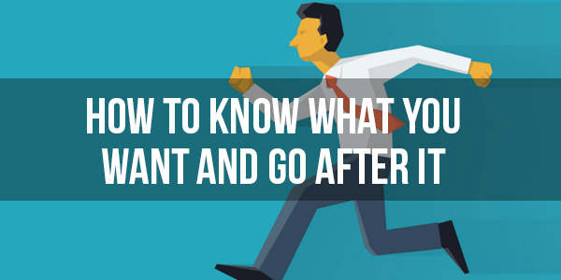
Chapter 7: How to Know What You Want and Go After It

In the last couple of chapters, we’ve focussed on using CBT to reduce stress. And we’ve seen how this can indirectly lead to advancements in your career thanks to things like the law of attraction.
But what about motivating yourself toward something? What if you’re not frozen by fear and stress but simply by tiredness and indifference? What if you don’t know what it is you want out of life, or how to structure a goal so that you can get there? You can’t very well work toward what you want when you don’t know what that is!

Vision, Not Goal
The first thing we’re going to do is to introduce just a very subtle shift in the way you approach these ideas. And specifically, this will mean having a vision and not a goal.
What is the difference between a vision and a goal? A vision is much more abstract but at the same time, more tangible.
A goal is to lose 1 stone in 10 weeks. A vision is to be the same you, but fitter, healthier and more attractive – running outdoors with a healthy looking tan and waking up every morning with tons of energy to get up and attack the day.
Which of those things is more motivating? For most people, the answer will be the vision.
The other great thing about visions is that most of us already have them, even if we don’t know it. If I ask you what your goal in life is, then you might not be able to answer. But if I ask you to just imagine your perfect life, then you might find it easier to do. Perhaps you’re sitting on a beautiful beach somewhere? Perhaps you’re living in a massive mansion? Maybe you’re rich in a skyscraper somewhere?
If you’re still struggling to come up with a vision that you can work toward, then some other questions to ask are things like: who are your role models (and what do they have in common)? When was the last time you were truly happy? What did you want to be when you were a kid?
It doesn’t have to be super concrete – wanting to be rich, wanting more time with your family or wishing you weren’t at work is fine! And if you do have something really concrete – wishing you were a famous rock star – then that’s fine too.
From here, the next thing to do is to take that vision and break it down into steps. This is another important point and it’s once again something that a lot of people get wrong. If you are working toward a goal rather than a vision, then you might, as per our previous example, be working toward losing X amount of weight in N amount of time.
This is a fine aim but it’s far too distant and too outside your control to be useful. When it comes to the crunch and you need to force yourself out the door to exercise, it’s all too easy to just tell yourself you’ll catch up on what you’ve missed later. You end up putting it off or making excuses and by the time that amount of time has passed and you haven’t achieved what you were hoping, you just feel disappointed, disheartened and possibly depressed. Eventually, this leads to you giving up entirely!
So instead, we make steps toward our vision. This means coming up with a plan first and often you’ll find it’s easier than you think to accomplish the impossible – it just requires a bit of creative thought. For example, if you want to be a rock star you might take a less obvious route such as creating your own YouTube channel and posting your music regularly. If you build up a big enough following and you have enough obvious skill, then eventually this is highly likely to lead to an offer for a recording contract!
In other scenarios it might be a very easy set of steps – in order to lose weight you might eat no more than 1800 calories every day and workout five times a week for 30 minutes. If you want to write a best selling novel, your goal might be to wake up one hour early and write for 40 minutes before work.
These are now incredibly simple steps that are highly within your control. You either fail or pass but it’s entirely down to you. And if you do fail? You can simply try again the next day. Each day is a fresh challenge and there is no putting things off. Ultimately, this makes a goal much easier to stick to – especially if you use the chain technique a lot of people use: creating a string of X’s in a calendar so that you will find yourself not wanting to break the sequence by missing a workout or writing session!
This will seem detached from the goal at times but if the steps are good, then taking them every single day, week or month on a consistent basis will mean you’re getting gradually closer to your aim.
Now all that’s left is to motivate yourself and to get yourself in a mind set where you’re willing to put in the time and work to get to where you want to be. How do you get yourself to get out of bed to go for a run at 5am when it’s pouring with rain outside?
The answer is that you need to use a slightly altered form of CBT by focussing on the emotional reasons behind what you’re doing. In other words, you need to think about the vision and you need to feel the vision. This is what will give you the release of the correct neurotransmitters to have the motivation to do it. You can also focus on what it is you’re trying to avoid.
So if you’re thinking about running in the morning and you can’t find the willpower to do it, the answer is just to make the connection in your mind so that you link that step to the outcome you want. Visualize that version of yourself who is fit, healthy and ripped and picture yourself running in the sun during the summer. Think about how it feels to never have this low energy and think about the alternative – getting gradually less and less fit and feeling gradually worse and worse with nothing that you can do to fix it.
And if you try this a few mornings and you find it doesn’t work, then another consideration is to try setting yourself up some kind of video or script that you can read or watch when you wake up to do that for you. Feel the emotion, know that the step you’re considering is what can get you there and then take the next step!

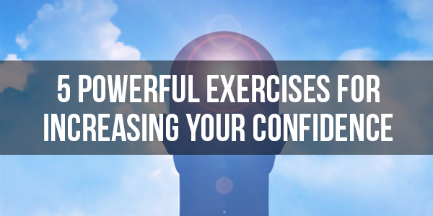
Chapter 8: 5 Powerful Exercises for Increasing Your Confidence

One of the most powerful assets in your mental arsenal is to increase your confidence – to feel good about yourself so that you can attract the things you want and so that you can give off an aura of being in charge and being passionate about what you’re saying.
But if you’re naturally someone who struggles with self-confidence, how can you simply ‘switch off’ that self-doubt and become more confident. Confidence is what turns thought into action – which is kind of what we’re all about.

Understand What Confidence Is
Confidence is a very broad term that gets thrown about a lot with careless abandon. This is a bit damaging because we tend to think of it as a single term that encompasses so much about who we are. We either have ‘good confidence’ or we have ‘bad confidence’.
In reality though, confidence is much more contextual than that. You can be confident in one domain and you can lack confidence in another. Maybe you think you’re ugly but you know you’re a fantastic writer – does that make you confident or unconfident?
So you can make yourself confident simply by focussing more on the things you’re good at in order to spend more time ‘at the top of your game’. At the same time though, you should also make sure you remember that your ability can improve in most areas. If you think you’re ‘bad’ at something, then remember that you’ll get better with practice and that everyone is bad to begin with. We’ve seen how neuronal connections strengthen as they fire and this is how you can become great at any given sport or activity over time.
What about your looks? Well, you can improve those in a lot of ways too. But it’s also useful to remember that everyone is different and that beauty is a very subjective matter. If you focus on your good qualities and own what you’ve got, you’ll be attractive to a lot of people.

Take Challenges
As mentioned, it’s useful to learn and to develop the things you’re not good at. This is why the hypothesis testing to become socially bulletproof is so useful – you’re exercising your social skills, just like you exercise a muscle.
As you get better in these areas, you’ll find that your confidence naturally improves because you have more strings to your bow and fewer areas that you consider to be flaws. But more important than this even is the psychology of simply trying new things and taking on new challenges. Each little ‘win’ will flood your brain with positive hormones and reward you and that will make you more inclined to try again. Try learning small things like juggling or learning to count in another language, each time you have a little victory it will improve your confidence and help you become better at taking on newer challenges.
Meanwhile, the failures you encounter will help to make you more accustomed to sometimes picking yourself back up and more desensitized to the feeling of failing at something. Again, this builds confidence.
If you’re looking to increase social confidence and self-worth, one of the very best things to do is to throw yourself into a challenging and outward-facing job. You’ll then have no choice but to make calls, great clients and learn new things and each time you do, your esteem will grow.

Visualize Success
Before trying something new, visualize yourself succeeding. This can help you to activate brain areas as though you really had succeeded and that will help to quash any doubt and boost your confidence. You can enhance this further by listening to some empowering music and reminding yourself that it’s a challenge and not an obstacle.
Better yet, if you keep practicing this it can eventually become habit – meaning that you’ll automatically visualize yourself succeeding in future when taking on any new challenge!
Power Poses
Power poses are positions you hold that have been shown to boost testosterone and thereby confidence. Try standing up and holding your arms over your head in a ‘V’ shape as though you had just crossed the finish line in a race. This is a universal stance that symbolizes success and it can really help to increase your drive and determination.
Invest in You
Finally, invest in yourself. If you treat yourself well for long enough, you will feel as though you deserve to be treated well. What’s more, wearing nice clothes, maintaining good health and having a great home all help to build that internal picture of who you are and give you more self-esteem. It’s not a waste of time and money to buy a good suit – it’s an investment.
We’ve actually got one more strategy for improving confidence coming up in the last chapter, so stay tuned for that one!

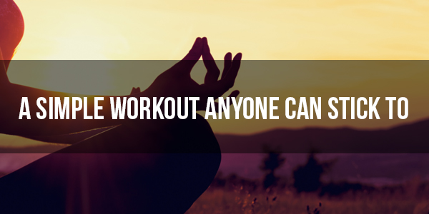
Chapter 9: A Simple Workout Anyone Can Stick To

As we’ve seen, a good workout can help to improve your mental energy, as well as your confidence and your drive. It also helps you achieve a wide range of things by giving you more mental and physical prowess. For many people, getting into shape is the goal in itself!
So let’s take a look at a workout that’s suitable for anyone and that anyone can give a try.

The Workout
This workout is a 21 minute circuit that will hit every muscle in your body while at the same time helping you to burn calories and improve your fitness. The aim is to do this first thing in the morning before your shower. Before the shower is important because it will allow you to save time versus having to shower twice. You can do this easily from home and all you need in terms of equipment is a pull up bar in your doorframe.
The workout itself is as follows:
1 Minute of Pull Ups
1 Minute of Press Ups
1 Minute of Tuck Jumps
1 Minute of Incline Push Ups
1 Minute of Chin Ups
1 Minute of Jump Squats
1 Minute Rest
Repeat 7 times for a total of 21 minutes and attempt to do as many repetitions as fast as you can for each round.
Note that pull ups mean your hands are facing away from you and your arms are wider, while chin ups have your hands facing inward and closer together. Jump squats are simply squats with bodyweight where you jump at the end.
If you want to make this workout more difficult, then you can replace it with a range of other movements. For instance, performing kettlebell swings instead of squats is a great option that will build a lot of muscle in the lower body and burn a lot of fat. Likewise, you could change the chin ups for bicep curls if you own a pair of dumbbells.
If you find the workout too hard on the other hand, then you can go slower and perform fewer reps and you can find ways to make the moves easier – for instance by doing push ups on your knees, or by doing pull ups with your feet lightly resting on a chair underneath you so that you can help yourself up with your legs.
The idea is to improve and make the workout more challenging over time but what you’ll find is that just by repeating this simple routine five times a week, you’ll see your body tone over time.
As a way to build motivation this is also a great tool – if you can find the motivation to do this on a regular basis, then you’ll find that you find it much easier to force yourself to do other things that you don’t want to do. Motivation, much like practically everything else, can actually be trained!

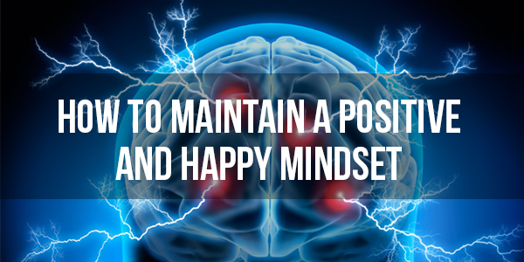
Chapter 10: How To Maintain a Positive and Happy Mindset

Everything we’ve looked at already should help you to find the things you want in life and to go after them. But what about being happier the way you are right now?
Because that’s the thing. A lot of us don’t realize that we could actually be very happy with what we already have. We see lions everywhere where there aren’t any and our society is designed only to encourage this further. Capitalism is all about convincing us that we need and want things that we don’t really. In reality, you can live very cheaply and be incredibly happy. How about moving to a poorer area and seeing your money go much further? And instead of spending lots of money on games and films, how about going for walks, exercising or even visiting free museums? A book on Amazon costs $1!
One study demonstrated this incredibly well. The research essentially gave lots of people a test to measure their happiness. Among the participants, some people had terrible luck – losing partners, losing limbs, contracting terminal illnesses – and others had much better luck by winning the lottery or marrying super models. Right after these life events, their happiness was measured again and as you wold expect, lottery winners were happier than amputees!
But now fast forward 10 years and what they found was that the happiness evened out again. This is once again what’s known as the ‘hedonic treadmill’. It’s a consistent sense of mild dissatisfaction that keeps us motivated and that prevents us from appreciating what we have.
The problem here is focus. And this is the final piece of the puzzle when it comes to changing your mindset and being happier with yourself.
If you choose to focus on the negative things in your life, then your life will always be negative. If you focus on stress you’ll always be stressed. But focus on the things you have and take the time to actually be mindful about your accomplishments, your good health and all the things you have to look forward to and suddenly you can be a lot happier.
It’s even possible to reduce pain by not focussing on it – which is how meditation can be used as a form of analgesic among those who are incredible experienced at it.
And this is also that other way you can boost your confidence – focus on the things that you like about yourself and all your accomplishments rather than the things you don’t like about yourself and over time, you’ll start to feel much more confident and much happier.

The Gratitude Attitude and Other Techniques
To make sure you start feeling happier about all those things you already have, consider trying to cultivate a gratitude attitude. The most popular way of doing this is through journaling – every night try and write down three things that you are grateful for and take a moment to reflect on this. With time, you’ll find that this makes you much more aware and much happier about everything in your life.
Another method is to try focussing on the things you’re looking forward. We tend to dread things we don’t want to do but how about instead you focus on things like your birthday, that new films you want to see, a holiday or even your favorite cereal tomorrow. Doing this gives you more to live for and helps you to drive forward to the next day.
And to make sure you have lots of things you can do without spending a fortune or getting stressed, try writing down ideas for activities as they come to your mind.
For boosting confidence, try writing down all the compliments that people pay you. Every time someone says something nice, remember it and then write it down. Every now and then you can read through this booklet and relive all those compliments!
Likewise, you can also use thought challenging to break down incorrect beliefs about yourself. If you feel you’re unattractive, then write down the things that you know are attractive about you – things no one can argue with. For a woman that might mean a thigh gap, back dimples or long brown hair.
To choose how you want to feel, you just have to just what you’re going to focus on and what’d going to get most of your attention.

Conclusion and Summary

A lot of this takes practice and comes with time, so don’t worry if you haven’t transformed yourself overnight. The first step though is simply recognizing that all this comes from within.
Your happiness, your goals, your fears, your drive, your personality… all of it is based on how you direct your attention and interpret what’s happening. Once you learn to go against thousands of years of evolution and take control of your emotions and neurotransmitters, suddenly they become a powerful tool that you can use to get a competitive edge in any aspect of your life.
You can be happier, more focussed, more confident and more efficient and driven. And when that happens, everything changes – the way people see you, the way you feel about yourself and the way opportunities start to present to themselves.
So where do you go from here? How do you start putting all this into action? We have included resource sheets and cheat sheets to help you take the next steps but for now, try to think more about the contents of your thoughts and how they’re holding you back.
When are you focussing on the negatives instead of the positives? What is causing your anxieties and fears? Write down your emotions and your thoughts and then challenge them – break them down on paper and test them where necessary.
Next, start to think about what you want to get out of life. Have a vision and not a goal and make sure that you live in that vision. Feel the emotion that comes from your vision and let it drive you so that you take each necessary step to get there.
But don’t forget to smell the roses along the way! Be mindful of the things you’ve already accomplished and the things you’re grateful for. The real trick is learn to be happy with who you are and to enjoy every challenge that life throws at you!

